Name: _______________________ Class: __________ Date: _______
Instructions: Write answers in the right-hand column. Score: ___________ / 50 marks
Section A— Multiple choice (10marks)

 | When using a machine called a force multiplier you apply:  A a small force over a large distance  B a large force over a large distance  C a small force over a small distance  D a large force over a small distance | A | 1
 | A machine that lifts a 60 N load with an effort of 20 N has a mechanical advantage of:  A 120  B 1200  C 2  D 3 | D | 1
 | The force you need to move an object is called the:  A frictional force.  B effort.  C load.  D resistance | B | 1
 | An eggbeater can be classed as a:  A force multiplier.  B speed multiplier.  C distance multiplier.  D time multiplier. | B | 1
 | When a ramp is used by removalists to lift a piano into a moving van, compared to lifting the piano vertically up:  A the force needed is reduced but the distance over which it acts is increased.  B the distance is increased, but the force required is the same.  C the force needed is reduced and this acts over a shorter distance.  D the force required is increased but the distance over which it acts is reduced. | A | 1
 | A tennis racquet is an example of a:  A force multiplier.  B mass multiplier.  C speed multiplier.  D time multiplier. | C | 1
 | Tweezers, tongs and cricket bats are all examples of  A first-class levers.  B second-class levers.  C third-class levers.  D wedges. | C | 1
 | Indigenous stone tools were developed by a process called:  A striking.  B chipping.  C cracking.  D flaking. | D | 1
 | An axe is an example of a simple machine called a:  A screw.  B lever.  C wheel.  D wedge. | D | 1
 | The chain wheel sprocket on a bike has 60 teeth and the rear wheel sprocket has 15 teeth. The gear ratio for this bike is:  A 90  B 900  C 3  D 4 | D | 1
Section B— Short answer (30 marks)

- ` | a Identify whether this car jack is classed as a force or a speed multiplier:  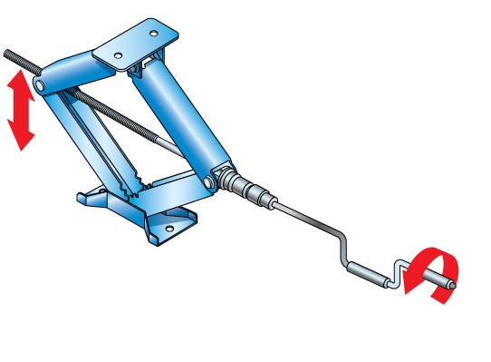  b Explain how a person using this machine is able to gain the mechanical advantage required to lift a car. | a Car jacks are classed as force multipliers.  b In using the jack, the handle is turned many times. In this way, the person using the jack applies a small force over a very large distance. This ensures that sufficient work is done to lift a car, even though the force required is quite low. | 2
 | Explain how a machine makes a task easier. | A machine makes a task easier by allowing it to be completed in a different way. For example, walking up ramp requires less force than climbing a vertical wall, but this small force is applied over a greater distance up the ramp. | 2
 | Explain how a wedge is used to split a piece of wood. | When hammered into a piece of wood, the wedge changes the direction of the force by 90 degrees. This force pushes the wood outwards from the wedge and splits it. | 2
 | Identify which three of the following machines are force multipliers:  wheelbarrow, nutcracker, broom, cricket bat, scissors, tongs, eggbeater | wheelbarrow, nutcracker, scissors | 3
 | Jim and Kai have a lever positioned underneath a heavy rock that they are trying to shift. They are trying to work out where to place a smaller rock to use as a fulcrum in order to lift the heavy rock with the least effort.  Jim thinks they should put the fulcrum as close to the heavy rock as possible. Kai thinks they should put the fulcrum as far away as possible from the heavy rock. Explain who is correct and why. | Jim is correct. If they place the fulcrum close to the heavy rock and push on the lever, the distance from the effort to the fulcrum is much longer than the distance from the load to the fulcrum. The longer this effort arm, the greater the mechanical advantage of the lever and the least effort they will need to use. | 2
 | Calculate the mechanical advantage of  a a machine that requires an effort force of 150 N to lift a 600 N couch  b a crowbar that requires a force of 80 N to shift a 240 N rock. | a Mechanical advantage =  = 600/150  = 4  b A crowbar that requires a force of 80 N to shift a 240 N rock.  Mechanical advantage =  = 240/80  = 3 | 2
 | The three simple machines illustrated here are all types of levers.  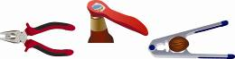  a Identify on each diagram the position of the fulcrum, effort and load forces in each case.  b Use this information to classify each as a class of lever. | a  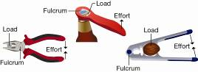  b The pliers are a first-class lever.  The bottle opener is a second-class lever.  The nutcracker is also a second-class lever. | 6
 | Look at the two levers, Lever A and Lever B shown below.  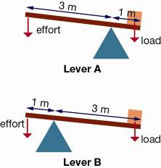  a Identify whether these levers are first-, second- or third-class levers.  b Calculate the mechanical advantage of Lever A and Lever B.  c Explain why one lever has a greater mechanical advantage than the other. | a These levers are both first-class levers.  b Mechanical advantage of Lever A  =  = 3/1 = 3  Mechanical advantage of Lever B  =  = 1/3 = 0.33  c The lever arm, or distance between the effort and fulcrum, is long in Lever A compared to the distance between the load and fulcrum. This means that the effort force is applied along a greater distance than happens when using Lever B. This provides Lever A with a much greater mechanical advantage than Lever B. | 5
 | Look at the ramp shown below.  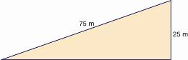  a Calculate the mechanical advantage provided by this ramp.  b Explain how an inclined plane provides a mechanical advantage. | a Mechanical advantage provided by this ramp  = = 75/25 = 3  b The force applied to overcome gravity and to raise an object through the vertical height of the ramp is applied over a greater distance than it would be if the object was lifted vertically. As a result, a smaller force is required. This explains how a ramp provides a mechanical advantage. | 2
 | Lily uses three identical pulleys; one in Pulley System A and two in Pulley System B, to lift a 100 N weight.  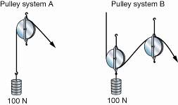  a Identify which pulley system needs a greater effort force to lift the weight:  b State which pulley system has the greater mechanical advantage.  c Explain how this mechanical advantage is obtained. | a Pulley System A requires the greater effort force to lift the weight. It requires a force of 100 N. Pulley System B requires only 50 N.  b Pulley System B has the greater mechanical advantage.  c Pulley System A had no mechanical advantage. It just changes the direction of the pulling force required to lift the weight.  Pulley System B has a mechanical advantage of 2. This means that only half of the original force is required to lift the weight (50 N), but this force is applied over twice the distance of cable than was applied in Pulley System A. The increase in distance provides the mechanical advantage. | 4

Section C— Thinking scientifically (10 marks)

 | The amount of work done when a force is applied to an object to move it is given by the formula:  Work done (J) = Force applied (N) × Distance moved (m)  Given this information, the work done in applying a force of 120 N to lift a crate of apples 3 m is:  A 120 J  B 40 J  C 360 J  D 400 J | C | 1
 | Sanjiv is using a metre ruler as a lever. The fulcrum of the lever is positioned at the end of the ruler that is attached to the stand and clamp as shown in the diagram. Sanjiv investigates how the effort force required to support the load changes as the position of the load shifts along the lever.  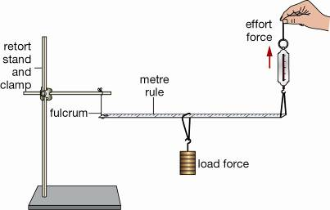  Study Sanjiv’s results table is shown below.  If the load was positioned 60 cm from the fulcrum, the effort Sanjiv would need to supply is  A 200 N  B 160 N  C 240 N  D 300 N | C | 1
  Distance of load from fulcrum (cm) | Effort (N)
  10 | 40
  20 | 80
  30 | 120
  40 | 160
  50 | 200
 | Use the following information to answer questions 3 and 4.  The mechanical advantage of a ramp is given by the formula:  Mechanical advantage =  A builder constructs a new ramp for use between a lower level car park and the ground floor of a shopping centre. The dimensions of the ramp are shown in the diagram.  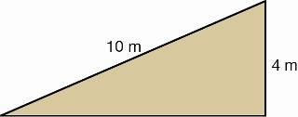  The mechanical advantage of the ramp is:  A 2  B 2.5  C 4  D 0.4 | B | 1
 | The builder realises he has made an error and that the ramp must reach a vertical height of 2.5 m instead of 4 m. Assuming the length of the ramp is the same, the new mechanical advantage is:  A 4  B 0.25  C 5  D 8 | A | 1
 | A number of interconnected gears are called a gear train. The force supplied is provided by the driving gear and force is transmitted to the driving gear.  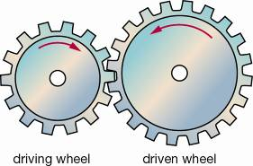  Select the correct response for the gears shown in the picture.  A The driving wheel rotates faster than the driven wheel.  B The driving wheel rotates slower than the driven wheel.  C The driving wheel and the driven wheel rotate at the same speed.  D The driving wheel and the driven wheel rotate in the same direction. | a | 1
 | A gear train incorporating an idler gear is shown in the diagram.  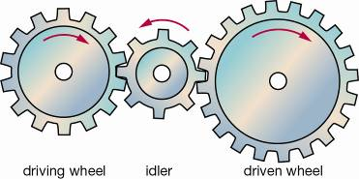  Select the correct response.  A The driven wheel rotates faster than the driving wheel.  B The driven wheel rotates slower than the driving wheel.  C The driven wheel rotates faster than the idler.  D The driving wheel rotates faster than the idler. | B | 1
 | Use the following information to answer questions 7 and 8.  A cable is positioned around a pulley as shown in the diagram below.  A 10 kg and a 15 kg mass hang from each end of the cable.  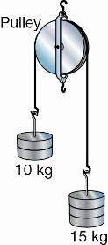  Select the correct response:  A The two masses are stationary.  B The 10 kg mass is moving downwards.  C The 15 kg mass is moving upwards.  D The 15 kg mass is moving downwards. | D | 1
 | An additional 5 kg mass is now added to the 10 kg mass in question 7. Select the response that describes what will now happen to the pulley system.  A The masses on the right and the left are stationary.  B The masses on the left are moving upwards.  C The 15 kg mass on the right is moving upwards.  D The 15 kg mass on the right is moving downwards. | A | 1
 | Use the following information to answer questions 9 and 10.  A hydraulic system transfers a force through an incompressible liquid. This force is transmitted using pistons of different surface area. The mechanical advantage of a hydraulic system is equivalent to the ratio of  Look at the hydraulic system shown in the diagram. The surface area of Piston 1 is 30 cm² and that of Piston 2 is 90 cm²  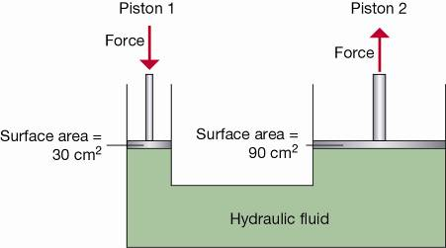  Over what distance was a force applied to Piston 1 if Piston 2 moves 3 cm?  A 1cm  B 3 cm  C 6 cm  D 9 cm | D | 1
 | If a force of 50 N is applied to Piston 1 (from question 9), the force supplied by Piston 2 is:  A 10 N  B 50 N  C 100 N  D 150 N | D | 1

